

**INTRAPARTUM NIPPLE STIMULATION TO INCREASE CONTRACTION IN PRIMIPARITY:**

**EVIDENCE BASED CASE REPORT**

*Intan Setiawati 1*, Santi Sofiyanti 2, Diyan Indrayani 3*

1*,2,3)Department of Midwifery, Poltekkes Kemenkes Bandung

Email: [intansetiawati@student.poltekkesbandung.ac.id](mailto:intansetiawati@student.poltekkesbandung.ac.id)

**Abstract**

**Introduction** Normal labor process duration varies between 4 to 24 hours since the occurrence of uterine contractions which cause changes in the cervix. Adequate contractions are needed to induce labor to proceed normally. The active phase of the first stage of labor is considered more tiring and painful because uterine activity increases. In this phase, there is often an increase in adrenaline production which has the potential to inhibit contractions and delay the labor process. Nipple stimulation is one method that can be used to increase uterine contractions. This technique can stimulate the formation of natural oxytocin in the mother and channel it to the uterus, thus it increases uterine contractions.

**Objectives:** This study aimed to find analyzed the effect of nipple stimulation on the labor progress and implement the best application of nipple stimulation

**Method**: This EBCR using the Google Scholar database and PubMed. The articles were limited to original article and published from 2017-2022. According to the inclusion criteria and exclusion criteria we have found 2 articles met the criteria. The articles were obtained and critically reviewed using 3 aspects, namely the validity, the importancy, and applicability.

**Result:**  in this study the duration of first stage of labor were considered faster after the application of nipple stimulation long first stage in cases. The first stage was 2 hours faster than the average duration of the first stage , which is 1 hour per 1 cm.

**Conclusion:** Nipple stimulation is one od the non pharmacological intervention that can be used an an option to increase the contraction during labor.

**Keywords:** nipple stimulation, intrapartum

**INTRODUCTION**

Childbirth is a series of processes that end with the expelling of the conception products from intrauterine to extrauterine. The initial stage of labor is the first stage, namely the opening and dilatation of the cervix, consisting of a latent and active phase. The latent phase is the start of regular contraction, followed by cervical dilatation up to 3 cm while the active phase is the interval after the latent phase which is followed by complete cervical dilatation (10 cm).1. Normal labor occurs 4-24 hours after uterine contractions occur which cause the cervical changes. As labor progresses, the contractions become more frequent, longer, and more intense. Adequate contractions are needed so that labor can proceed normally. In the first stage, the active phase is considered more tiring and painful because uterine activity increases. In this phase there is often an increase in adrenaline production, this hormone can inhibit contractions and delay the labor process. Adrenaline which consists of cathecolamine causes an increase in cardiac output and respiratory frequency. Apart from that, increased adrenaline causes a decrease in blood flow to the uterus and placenta. 2,3

Lack of blood flow to the placenta during labor causes the fetus to experience hypoxia and fetal metabolic acidosis. Meanwhile, reduced blood flow to the uterus reduces uterine contractions. Reduced uterine contractions will result in cervical changes because cervical dilatation and effacement will occur if there are adequate contractions. 4,5

However, not all mothers experience adequate contractions, some women need stimulation to increase contractions either pharmacological or non-pharmacological such as nipple stimulation. Theoretically, nipple stimulation increases oxytocin production which is needed to increase uterine contractions.6 Having adequate contractions can cause the cervix to flatten and open. This action can be stopped if the contractions experienced become strong and long.7

**CASE**

A 39-week pregnant woman came to a community health center complaining of frequent contractions since one day prior, she denied leakage of amniotic fluid. Fetal movement is still felt. The examination results of the abdominal palpation with fundal height 30 cm, cephalic presentation Leopold IV. Divergent, contraction 3x10'30'', fetal HR 136 x/minute, regular. Vaginal touche: vaginal vulva showed no abnormalities, soft thick portio, effacement 40%, dilation 2 cm, amniotic membranes intact, cephalic presentation, right anterior occiput, descendants station 0, no moulages, Bishop's score 7. The analysis results both mother and fetal conditions were normal, however, the contractions were considered weak, and thus the nipple stimulation was carried out. We evaluated the contraction after the nipple stimulation and found there was an increase of the duration and contraction strength with the frequency 4x10' and an increase of duration with 40 seconds in each contraction, fetal HR 142 x/minute regular.

An internal examination was carried out due to complaints of spontaneous discharge with the results increase of effacement 70%, cervical dilation 6 cm, clear color negative amniotic fluid, descendants station +1, moulages 0, Bishop's score 11. Nipple stimulation continued with the help of the husband.

At 19:10 WIB, the mother complained that the contraction was getting stronger and longer and there was an urge to urinate. The results of the examination showed that the mother was in the second stage of labor, we motivate the mother to push, the baby was born not long after being forced to push with a strong cry, reddish color, and strong muscle tone.

**METHODS**

We’ve conducted literature research using Pubmed and Google Scholar with the keywords "Intrapartum Nipple Stimulation", the articles were limited to 5 years from 2017 to 2022. The PICO tool was used for a fully comprehensive search, which is defined below:

Populations: Intrapartum mothers

Intervention: Nipple sitmulation

Comparison : No control group

Outcomes: Increase contraction, prevent prolonged labor

Keywords used: intrapartum nipple stimulation

Problem: The effectivity of nipple stimulation on labor contraction.

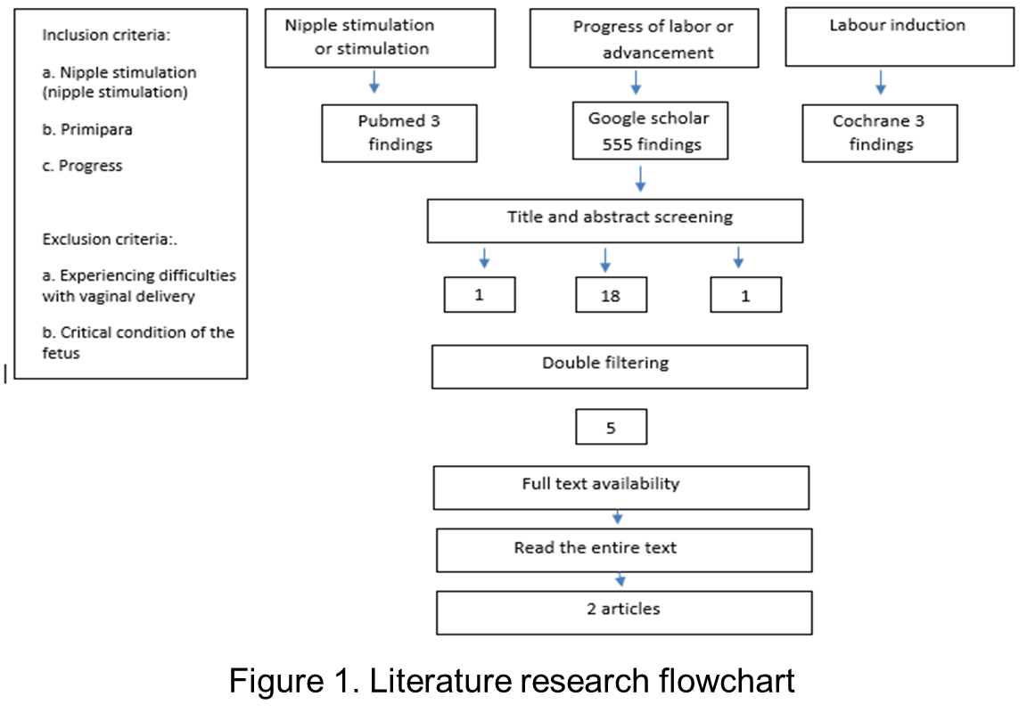 There were 555 articles on Google Scholar and 3 articles on Pubmed. 3 articles were selected based on inclusion and exclusion criteria and critically reviewed, which consisted of 3 aspects, namely research validity, clinical importance of the results, and their applicability or relevance to existing clinical problems. For each selected article, the degree of strength of evidence or level of evidence is also determined, which is depicted in a table, so that the table shows the precision, consistency, suitability, and controversy of the results, as well as which evidence is the best. The process of literature research is described in the figure 1.

**RESULTS AND DISCUSSION**

The articles were analyzed as described on table1.

|  |  |  |  |  |
| --- | --- | --- | --- | --- |
| **NO** | **JOURNAL** | **VALIDITY** | **IMPORTACY** | **APPLICATION** |
| 1 | *A Quasi Experimental Study to Assess The Effectiveness of Nipple Stimulation in The Progress of Labour Among Primipara Women During First Stage of Labour in Selected Hospital of Jabalpur (M.P).* 8  Rajni Soni, Vinitha Surresh  Indian Journal of Holistic Nursing 2019  Source: Google Scholar | The study was a quasi-design experimental post-test-only control group that was done over 8 months between February 2018 to September 2018. Sampling using the technique of non-probability purposive sampling. Respondent consists of 60 primigravida women Divided become 30 women in the experimental group and 30 women in the control group. | The results of this study stated that the bishop score in the control group was 23 (76.6) And 27(90%) in the group experiment.  There was a mean difference between the first stage duration and bishop score, but it was not statistically significant. | Nipple stimulation for 15 min alternatively during active phase |
| 2 | *Effect of Nipple and Uterine Stimulation on the Progress of Labor among Primiparous Women*9  Violet Nicola Ghattas, Nor El-Hoda Mohamed Hanan Ibrahim Ibrahim El-Said El-Shabory. International Journal of Novel Research in Health care and Nursing.  2020  Source: PubMed | This study uses a design comparative quasi-experimental. This study compared three groups, with one control group, and two intervention groups namely nipple stimulation and uterine stimulation group. Samples for each group were 50 pregnant women. 4 tools were used in the research - socio- demographic And clinical data through interviews  -bishop scores every 2 hours until delivery  -assessment of uterine contractions using the contraction test, frequency, intensity, and duration of the contraction. | Total bishop score, contraction intensity, duration, and frequency were significantly higher in the nipple stimulation group and uterine stimulation group. The average labor duration was also found significantly (p=0.000) shorter in the intervention group (both nipple stimulation and uterine stimulation). The use of oxytocin induction in the control group was significant (p=0.000) There was prolonged labor happened on the control group with a proportion of 25% from the samples. | Nipple stimulation is applied once every half an hour after contraction, during the first stage of labor. One nipple of the woman was rolled and gently pulled forward with the thumb and index finger for 2 minutes and the same procedure was then repeated with the other nipple |

The first article was a quasy experimental study using a post-test control group only, 60 samples were divided into two groups control and experiment. The experiment group was given nipple stimulation every 15 minutes during the first stage of labor while the second article applied the nipple stimulation every one hour during the first stage of labor.

The first articles compare the bishop scores and duration of the first stage between the two groups. There was higher satisfaction on Bishop score on the experiment group and it stated the mean of first stage duration on the experiment group was faster with the mean difference 3.71 hours. Based on the results table showed that the p-values were not statistically significant.

In the second article, the samples were divided into three groups, the research compared three groups, one control group, nipple stimulation group, and a uterine stimulation group. the uterine stimulation was applied on the uterus every half an hour using fingers, and the nipple stimulation was every half an hour using fingers, applied 2 minutes repeatedly. Bishop scores, contraction duration, frequency, and strength were performed to evaluate the effectiveness of nipple stimulation. The results showed statistical significance for all the variables and concluded that nipple stimulation was effective in increasing uterine contraction and shortened the duration of labor.

In the first article, both groups reported normal delivery with an average normal duration of the first stage, but in the second article, it reported 10 cases of the control group experienced prolonged labor.

Nipple stimulation is one method that can be used to increase uterine contractions. This technique can stimulate the formation of natural oxytocin in the mother's body and channel it to the uterus, causing contractions.10 Nipple stimulation can be done by the birthing mother or her partner.11 With adequate contractions, the cervix can flatten and open. This action can be stopped if the contractions experienced become strong and long.9

During labor, contractions are needed that continue to increase in strength and duration so that the cervix opens properly. Contractions can increase depending on various factors, but if the contractions do not increase then action needs to be taken. Stimulation of the nipples is one action that can be given as an alternative to increase uterine contractions.12 Contractions can become adequate when stimulation can be carried out correctly, the mother gets support and the mother has optimism in undergoing labor. The mother's comfort also needs to be considered because the stimulation is carried out on parts that are sensitive for a woman.12,13

**CONCLUSION**

The level of evidence in the articles that were reviewed was not high. Both articles used quasy experiment, however, we applied nipple stimulation with the consideration of low intensity of uterine contraction, and we didn’t find any risk in the case. The application of nipple stimulation in this case was performed with the husband's assistance. It was considered effective in increasing uterine contraction intensity. However, we strongly suggest examination of the presence of risks or abnormalities in fetal vascularization must be ascertained before implementing nipple stimulation in labor.

**REFFERENCES**

1. Hutchison JH, Mahdy H, Hutchison J. Stages of Labor [Internet]. Treasure Island. Treasure Island (FL): StatPearls Publishing; 2023. Available from: https://www.ncbi.nlm.nih.gov/books/NBK544290/

2. Yuksel H, Cayir Y, Kosan Z, Tastan K. Effectiveness of breathing exercises during the second stage of labor on labor pain and duration: a randomized controlled trial. J Integr Med. 2017 Nov;15(6):456–61.

3. Uwin, Sofiyanti S. Effectivity of Deep Breathing on State of Anxiety in Pregnant Women with Placenta Previa : EVIDENCE BASED CASE REPORT. J Kesehat Siliwangi. 2022 Apr 25;2(3 SE-):822–33.

4. Labor S, Maguire S. The Pain of Labour. Rev pain. 2008 Dec;2(2):15–9.

5. Turner JM, Mitchell MD, Kumar SS. The physiology of intrapartum fetal compromise at term. Am J Obstet Gynecol. 2020 Jan 1;222(1):17–26.

6. Stark EL, Athens ZG, Son M. Intrapartum nipple stimulation therapy for labor induction: a randomized controlled external pilot study of acceptability and feasibility. Am J Obstet Gynecol MFM. 2022;4(2):100575.

7. Citra T, Sofiyanti S. Laporan Kasus: Hubungan Seksual untuk Menstimulasi Proses Persalinan. J Kesehat Siliwangi. 2023;4(1):496–502.

8. Suresh V, Soni R. A Quasi Experimental Study to Assess the Effectiveness of Nipple Stimulation in the Progress of Labour among Primipara Women during First Stage of Labour in Selected Hospital of Jabalpur (M.P.). Indian J Holist Nurs. 2019;10(1):1–7.

9. Ibrahim H, Violet Nicola G, El-Shabory NEHMES. Effect of Nipple and Uterine Stimulation on the Progress of Labor among Primiparous Women. Int J Nov Res Healthc Nurs. 2021;8(2):169–80.

10. Sancaya RF. Pengaruh Stimulasi Putting Susu Terhadap Peningkatan His Pada Ibu Bersalin Kala Ii Di Rsud Cimacan Kabupaten Cianjur Periode April-Juni Tahun 2022. J Ilm Penelit Kebidanan Dan Kesehat Reproduksi. 2023;6(1):49–56.

11. Raana HN, Fan XN. The effect of acupressure on pain reduction during first stage of labour: A systematic review and meta-analysis. Complement Ther Clin Pract. 2020 May;39:101126.

12. Dashtinejad E, Abedi P, Afshari P. Comparison of the effect of breast pump stimulation and oxytocin administration on the length of the third stage of labor, postpartum hemorrhage, and anemia: a randomized controlled trial. BMC Pregnancy Childbirth. 2018 Jul;18(1):293.

13. Takahata K, Horiuchi S, Tadokoro Y, Sawano E, Shinohara K. Oxytocin levels in low-risk primiparas following breast stimulation for spontaneous onset of labor: a quasi-experimental study. BMC Pregnancy Childbirth. 2019;19(1):351.